Justin Winfield  
CSC 424 – Spring 2018  
Assignment 3

Problem 2

I chose CA (Correspondence analysis with few categorical columns that we have in our dataset) and all the code can be found in the CSC424_JustinWinfield_Assignment3.r file, where I created a contingency table and use the library ca package to create a plot

**Problem 3**

In this article, they try to understand decent work on work motivation among lawyers in Brazil and Portugal. They chose canonical correlation with two variates, the first is Decent Work Factors, which consist of *Fundamental Principles and Values at Work, Adequate Working Time and Workload, Fulfilling and Productive Work, Meaningful Retribution for the Exercise of Citizenship Social Protection, Opportunities, Health and Safety*. The second variate is on levels of Work Motivation, which includes Amotivation, *Extrinsic Material, Extrinsic Social, Introjected, Identified, and Intrinsic.* Each variate have variables that are using the Likert scale, Decent Work used a 5-point scale while the Motivation used a 7-point scale. In their results for the first canonical correlation, for Portugal, they saw high levels for *Fundamental Principles and Values at Work, Opportunities, Fulfilling and Productive Work, and Meaningful Retribution for the Exercise of Citizenship Social Protection.* In Brazil, they saw the same dimensions as well as *Adequate Working Time and Workload.* In the second canonical correlation, for Portugal, they saw positive relationship with Identified and Intrinsic motivation while Brazil saw the same thing. They concluded in both samples how first the canonical correlation associates on more autonomous work motivation, values, and meaning and the second one associates with working time, workload, and extrinsic motivations. Some of the results can be explained by the different age groups and the ratio of male and females in each of the samples. Overall, they can use the results to implement some work practices.

**Problem 4**

In this article, the researchers tried to understand vacation and its benefits among Chinese families since this is relatively new topic that hasn’t been quite studied especially since more Chinese families are having more income due to the rise of a middle class society. A survey was done with sample size of 306 families showing the results of benefits and activities for the Chinese families. The researches performed a Principal Component Analysis on the benefits variables to come up with 4 factors. From there, they performed a canonical correlation between the benefits factors and activities. What they found was the first canonical correlation pair saw a relationship between taking photos/videos with items under the Communication and Togetherness factor, the second variate saw visiting a historical site, shopping for art and crafts, enjoying local tastes and delicacies, and dining in an inexpensive local restaurant with Shared Exploration, the third variate saw escaping from the routine life and relaxing under the Escape and Relaxation factor, and the fourth variate saw several items under the Experiential Learning for Children. What they concluded was they saw benefits among Chinese families to be more child-centric which is shown based on the canonical correlations from the fourth factor and the activities as well. In one of the figures, it shows a reverse pyramid where shows the emphasis of the benefits, which children and family benefits are on the top.

**Problem 5**

**Part 1**

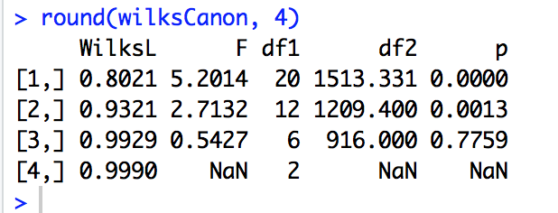

1. We can reject the null hypothesis that the first canonical correlations equal to zero F(20, 1513 d.f.)-value of 5.2014 and a p-value less than 0.0001
2. We can reject the null hypothesis that the second canonical correlation equal to zero F(12, 1209 df)-value of 2.7132 and p-value less than 0.05
3. 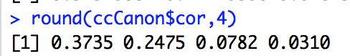
4. We can conclude that based on the Wilk’s test and the canonical correlations, 2 canonical variates can be used.

**Part 2**

First Variate

Attitudinal = -0.6348309(esteem)-0.7689471 (control)-0.712937(attmar)+0.1191717(attrole)

Health = -0.11823858(timedrs)-0.08445857(attdrug)-0.38882908(phyheal)-0.97959013(menheal)-0.22906107(druguse)

Second Variate

Attitudinal = -0.6439979 (esteem) -0.1040628(control)+ 0.3336807 (attmar)-0.7164603 (attrole)

Health = 0.28151460 (timedrs -0.59978939 (attdrug)+ 0.08083039(phyheal)+ 0.13655969 (menheal)+ 0.53887129 (druguse)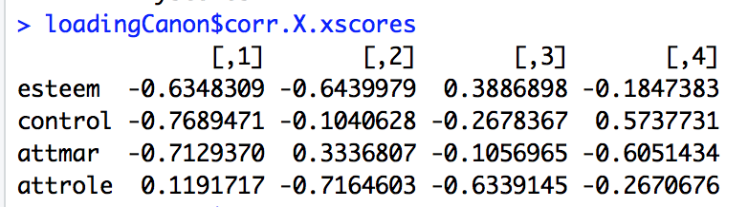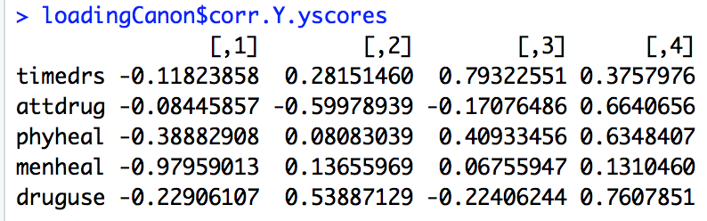

**Extra Credit**